2016 Hubert H. Humphrey Fellowship Program

PROFESSIONAL DEVELOPMENT IN THE UNITED STATES

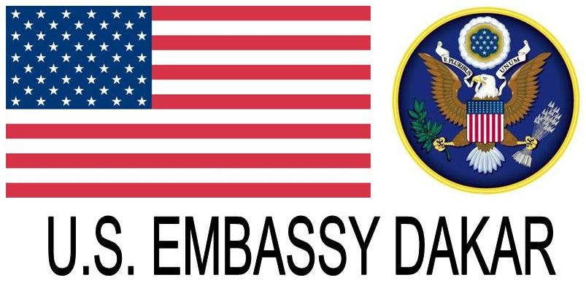

Public Affairs Section
U.S. Embassy
Route des Almadies
DAKAR

DEADLINE IS
May 20, 2015
For more information, send an e-mail to:
FulbrightSenegal@state.gov

Grant Provisions:
- Round-trip economy
international travel for the grantee.
- Tuition and university fees.
- Limited accident and sickness insurance for the grantee only.

Call for applications
The U.S. Embassy is pleased to announce the 2016 Hubert Humphrey Fellowship Program.
This one year, full-scholarship program is offered to mid-career professionals working at policy-level who have a record of leadership, a commitment to public service, and the initiative to take full advantage of a self-defined program of independent study at a leading American university.

The Hubert H. Humphrey Fellowship Program brings accomplished professionals from developing countries to the United States at a midpoint in their careers for a one-year program of non-degree study and related professional activities. The program seeks to foster an exchange of knowledge and mutual understanding between American citizens and professional counterparts from Senegal. Successful applicants will be placed at participating universities in the United States for the August 2016-June 2017 period.

Fields of Study
Fellowships are available in the following fields:

Sustainable development
- Agricultural and Rural Development
- Economic Development/Finance and Banking
- Natural Resources, Environmental Policy, and Climate Change
- Urban and Regional Planning
Democratic Institution Building
- Communications/Journalism
- Law and Human Rights
- Public Policy Analysis and Public Administration
- Trafficking in Persons Policy and Prevention
- Technology Policy and Management
- Human Resource Management
Education
- Educational Administration, Planning and Policy
- Higher Education Administration
Public Health
- Public Health Policy and Management
- HIV/AIDS Policy and Prevention
- Substance Abuse Education, Prevention, and Treatment.
Eligibility Requirements: To be eligible for the Humphrey Fellowship, applicants must have:
- Senegalese citizenship
- A Master’s degree
- Five years of substantial professional experience
- Demonstrated leadership qualities and a record of public service
- Fluency in English (candidates will sit for the TOEFL test)
Application/Selection Process
More information can be found from: https://humphreyfellowship.org/
Interested candidates must apply via the following website: http://apply.embark.com/student/humphrey/fellowship/

